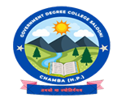

**GOVERNMENT DEGREE COLLEGE SALOONI, DISTRICT CHAMBA (HP)**

**EDUCATIONAL TRIP 2024-25**

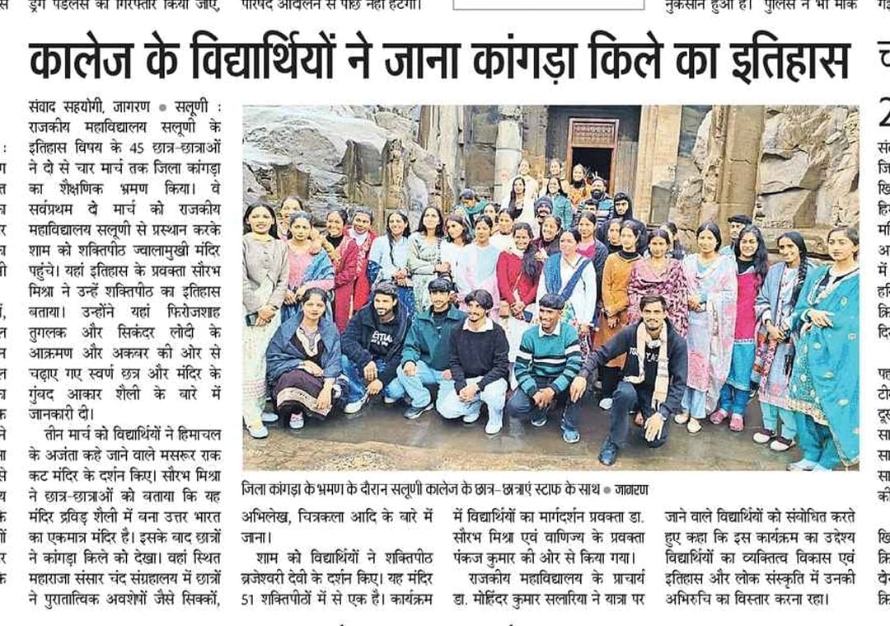**(2ND MARCH TO 4TH MARCH 2025)**

